

Section 2: I Wish I Could – Dream Freely, Think Boldly

Jeanine Osborne Szeles
+27742339492



PRE-WORK

Section 2: I Wish I Could – Dream Freely, Think Boldly
Shift into a mindset of possibility. Review the business plan through the lens of your function and imagine what you could achieve if limitations didn’t exist. This module inspires participants to dream of outcomes that improve career progression, company performance, and work-life balance.
Outcomes:
- Align your aspirations with the business context
- Envision a high-impact, personal outcome
- Set the foundation for a meaningful coaching goal

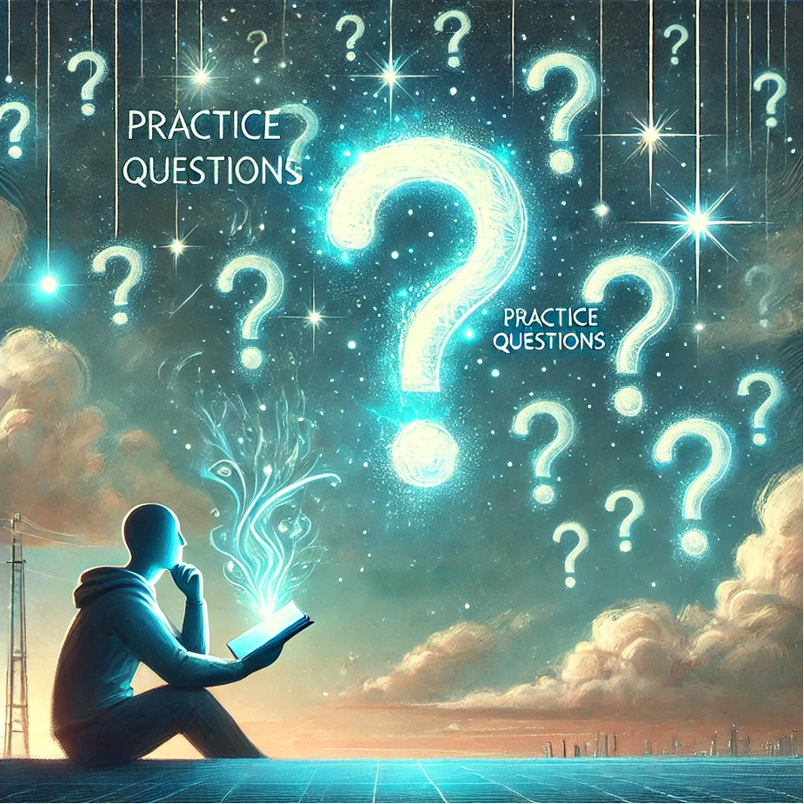

Complete this worksheet as a personal reflection, as part of your coaching program to demonstrate your understanding of the company’s foundation and your strategic alignment.

I Wish I Could Alignment Template

Section | Guiding Question
Business Plan Highlights | What 1-2 elements from the Business Plan inspire you? (e.g., Vision, growth opportunities)
Current State | How do you feel about your career and work-life balance now?
My Wishes | List 3 “I wish I could…” statements.
Chosen Wish | Pick one and describe it in detail.
Alignment and Impact: Career | How would this wish advance your professional growth?
Alignment and Impact: Company  Section 2: I Wish I Could – Dream Freely, Think Boldly  Shift into a mindset of possibility. Review the business plan through the lens of your function and imagine what you could achieve if limitations didn’t exist. This module inspires participants to dream of outcomes that improve career progression, company performance, and work-life balance.  Outcomes:  - Align your aspirations with the business context  - Envision a high-impact, personal outcome  - Set the foundation for a meaningful coaching goal | How would it support the Business Plan or mission?
Alignment and Impact: Work-Life Balance | How would it improve your personal well-being?
Function Role | What could your role or team do to make this wish possible?

From Wishes to Vision – Guided Worksheet & Checklist
This worksheet helps you reflect on your current experience, dream about what could be, and connect your personal aspirations with your company’s strategic direction. Use this guided exercise to move from wishful thinking to aligned vision.

Step 1: Reflect on Your Current State

✔ Review your Business Plan summary (Section 1):

Which 1–2 key elements resonate with you or your function?

1. ________________________________________________________________________

2. ________________________________________________________________________

✔ How would you describe your current career satisfaction and work-life balance?
________________________________________________________________________

________________________________________________________________________

Step 2: Dream Your To-Be State

✔ Complete this sentence three times: 'I wish I could…'

1. I wish I could ___________________________________________________________

2. I wish I could ___________________________________________________________

3. I wish I could ___________________________________________________________

✔ Choose one wish and expand it:

What would achieving this wish mean for your career?
________________________________________________________________________

What benefit would it bring to your company or team?
________________________________________________________________________

How would it improve your work-life balance or personal well-being?

________________________________________________________________________

Step 3: Connect the Dots

✔ How does this wish align with the Business Plan?

________________________________________________________________________

✔ What role could your function play in making it real?

________________________________________________________________________

Deliverable
Write a 5–7 sentence summary of your chosen wish, its impact on your career, company, and personal life, and how it aligns with your Business Plan.

________________________________________________________________________

I Wish I Could – Guided Reflection Worksheet
This worksheet is designed to help you unlock your imagination and define a powerful personal or professional aspiration. You’ll explore what excites and inspires you, and then connect that vision to your company’s strategic direction to make it actionable.

1. Dream Without Limits

If you could do or change anything in your role or career, what would it be?

________________________________________________________________________

________________________________________________________________________

What would your workday look like if it was more aligned with your strengths and passions?
________________________________________________________________________

2. Describe Your Wish

Complete the sentence: 'I wish I could...'

________________________________________________________________________

What would achieving this allow you to feel, contribute, or become?

________________________________________________________________________

3. Connect It to Your Organisation

How could your wish support your company’s Vision, Mission, or growth opportunities?

Does it address a challenge or opportunity identified in your Business Plan (Section 1)?

________________________________________________________________________

4. Make It Tangible

What’s one small step you could take to begin moving toward your wish?

________________________________________________________________________

What support or resources might help you take this next step?

________________________________________________________________________

5. Your Statement of Intent
Write a short 3–5 sentence statement summarising your 'I Wish I Could' vision, why it matters, and how you plan to begin making it real.

________________________________________________________________________

‘I Wish I Could’ – Strategy & Vision Reflection Worksheet
This worksheet helps you align your personal aspirations with your organisation’s purpose. You’ll reflect on your company’s foundations, clarify your role within that context, and dream big about the kind of future you’d love to help create.

1. Review the Business Plan

What is your company’s Vision?

________________________________________________________________________

What is its Mission?

________________________________________________________________________

What growth opportunities did you identify in Section 1?

________________________________________________________________________

2. Align Your Function

What role does your function play in supporting the company’s Vision and Mission?

________________________________________________________________________

Which teams or systems depend on your work?

________________________________________________________________________

Are there challenges or gaps your function could help solve?

________________________________________________________________________

3. Dream an Outcome

Imagine your work at its best — what would it look like?

________________________________________________________________________

How could this positively transform your career or team?

________________________________________________________________________

What would this vision mean for your work-life balance or personal satisfaction?

________________________________________________________________________

4. Reflect. Imagine. Connect.

How does your 'I Wish I Could' idea support the company’s growth or purpose?

What is one small step you could take toward this vision?

________________________________________________________________________

What support, tools, or conversations would help bring it to life?

________________________________________________________________________



Frameworks:
The following framework can be used in supporting your plan development.

Creative Vision-to-Action Framework
This framework guides participants through a structured yet imaginative journey — from personal insight to actionable, aligned innovation. Each stage builds clarity, connection, and collaboration.

1. TRUTHS: Two Truths and a Wish
Purpose: Unlock honest self-reflection and imagination.
Instructions:
• Write down two things you know are currently true about your role or team.
• Then, write one wish – a hopeful possibility you'd love to see happen.
Example:
- Truth: We always meet our deadlines.
- Truth: Our meetings often feel unproductive.
- Wish: I wish we had more creative space to solve problems together.

2. FUNCTIONAL ALIGNMENT: Personal and Functional Alignment
Purpose: Ground aspirations in real responsibilities.
Instructions:
• Reflect on how your personal goals align with your functional responsibilities.
• Ask: How does my role support my team? How does it connect to our mission?
• Identify 1–2 key alignment points and 1 possible misalignment to explore.

3. I WISH I COULD: Brainstorming Bold Aspirations
Purpose: Unlock creative ambition with strategic intent.
Instructions:
• Complete the phrase 'I Wish I Could…' at least 3 times.
• Don’t hold back – dream big, practical or not.
• Then, choose the wish that resonates most and outline how it could improve your work, your team, or the company.

4. IDEAS ALIGNMENT: Idea Alignment and Selection
Purpose: Move from brainstorming to viable concepts.
Instructions:
• Compare your top wish/idea with company goals, values, or priorities.
• Use a simple fit test: Does this idea support our mission? Is it feasible? Who benefits?
• Select the top 1–2 ideas to take forward for refinement.

5. REFINE IDEAS: Present, Feedback, Refine
Purpose: Improve ideas through collaboration.
Instructions:
• Present your idea(s) to a small group.
• Invite open, constructive feedback.
• Record suggestions and refine your idea to increase clarity, feasibility, and impact.
• Finalise your concept in a short paragraph or sketch.

Framework Table – Creative Vision-to-Action
Framework Step | Activity Name | Purpose
1. TRUTHS | Two Truths and a Wish | Unlock honest self-reflection and imagination.
2. FUNCTIONAL ALIGNMENT | Personal and Functional Alignment | Ground aspirations in real responsibilities.
3. I WISH I COULD | Brainstorming Bold Aspirations | Unlock creative ambition with strategic intent.
4. IDEAS ALIGNMENT | Idea Alignment and Selection | Move from brainstorming to viable concepts.
5. REFINE IDEAS | Present, Feedback, Refine | Improve ideas through collaboration.

