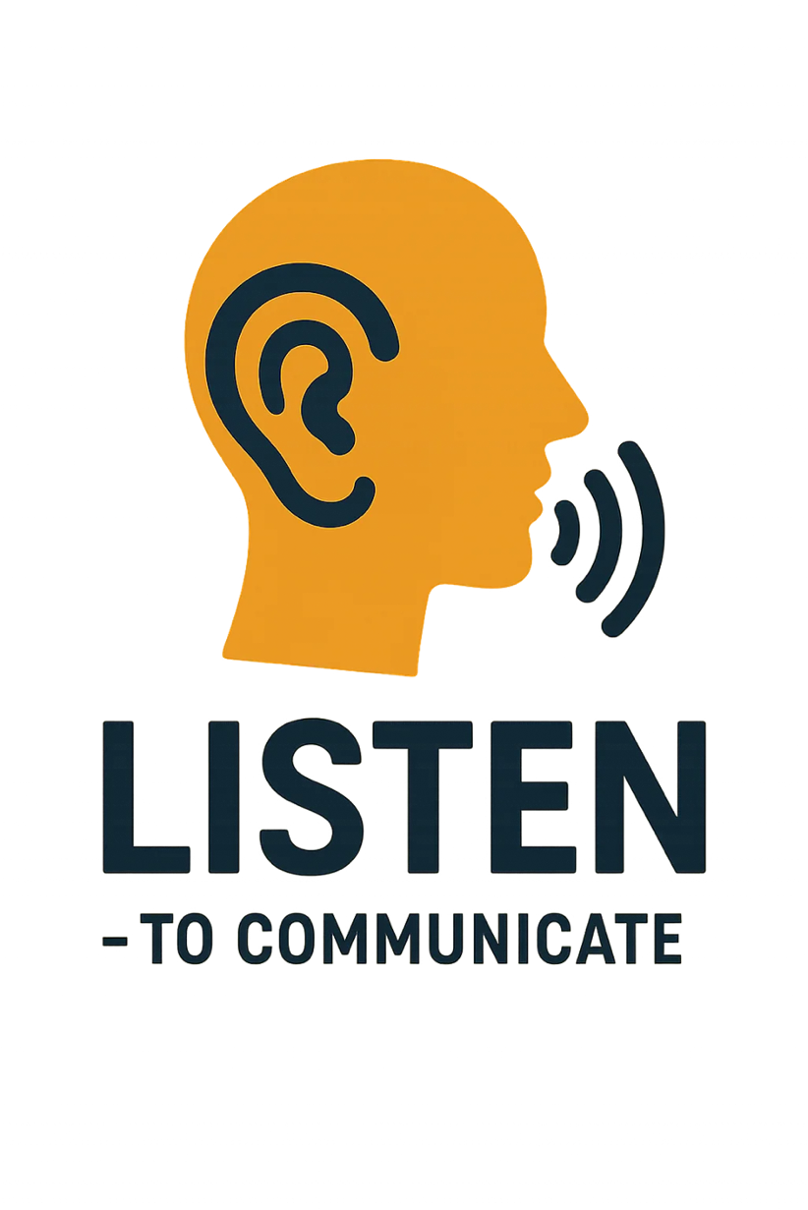

**Section 1**

**Active Listening Resources and Templates**

Contact: Jeanine Osborne | +27742339492 | [jeanine@virtualstudent.online](mailto:jeanine@virtualstudent.online)

### 📘 ****Section Introduction****

Each section in this course is designed as a **self-learning experience**, allowing you to work through the material at your own pace.

You will:

* **Follow the steps** as outlined in the downloadable workbook or document
* Engage with **scenarios and templates** to complete your practical exercises
* Submit your **downloadable assignment** for grading and feedback
* Complete a **multiple-choice quiz**, which will be **automatically graded**

Additionally, a **1-hour weekly live session** will be scheduled via the **BigBlueButton calendar**. During this session, we will discuss:

* Feedback on your exercises
* Challenges and breakthroughs you've experienced
* Key takeaways and shared learning

🔔 **Important:** Attendance at your designated session is essential. If you are unable to attend, **deferred sessions will incur an additional cost**.

Make the most of each section by engaging fully, asking questions, and applying what you learn. Your growth starts here!

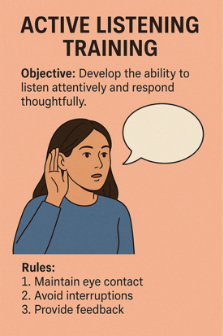

S1 | Active Listening Training

* **Objective:** Develop the ability to listen attentively and respond thoughtfully.
* **Activities:**
  + **Listening Exercises:** Pair employees to practice listening without interrupting, then paraphrase what was heard.
  + **Feedback Sessions:** Encourage giving and receiving constructive feedback based on listening exercises.

Below is a comprehensive **Module** designed to help employees assess their current communication skills. This module includes objectives, activities, tools/resources, and expected outcomes to ensure a thorough evaluation and identification of areas for improvement.

### **Module: Assessing Current Communication Skills**

#### **Module Overview**

This module is designed to help employees evaluate their current communication skills within the workplace. By conducting surveys and assessments, employees can gain a clear understanding of their strengths and areas that require improvement. This self-awareness is crucial for personal development and enhancing team collaboration.

### **Module Objectives**

* **Understand Current Communication Landscape:** Gain insights into existing communication practices and dynamics within the team and organization.
* **Identify Strengths and Weaknesses:** Recognize personal and collective communication strengths and areas needing improvement.
* **Facilitate Personal Development:** Provide actionable feedback and resources to enhance communication skills.
* **Promote a Collaborative Environment:** Foster an environment where effective communication is prioritized, leading to better teamwork and productivity.

### **Module Components**

### ****Surveys and Assessments | Utilize structured surveys and assessments to evaluate current communication skills and practices.

### ****Data Analysis | Analyze survey and assessment results to identify trends, strengths, and areas for improvement.

### ****Feedback Sessions | Provide personalized feedback to employees based on their assessment results.

### ****Action Planning | Develop individualized action plans to address identified communication gaps and leverage strengths.

### ****Follow-Up and Evaluation | Monitor progress through follow-up surveys and assessments to ensure continuous improvement in communication skills.

### **Detailed Activities**

#### **A. Surveys and Assessments**

|  |  |  |
| --- | --- | --- |
| ****Activity**** | ****Description**** | ****Tools/Resources**** |
| ****Communication Skills Survey**** | Distribute a comprehensive survey to assess various aspects of communication, including verbal, non-verbal, listening, and feedback skills. | Online survey platforms (e.g., SurveyMonkey, Google Forms) |
| ****360-Degree Feedback Assessment**** | Collect feedback from peers, supervisors, and subordinates to provide a holistic view of an employee’s communication effectiveness. | 360-degree feedback tools (e.g., Qualtrics, BambooHR) |
| ****Self-Assessment Questionnaire**** | Encourage employees to self-evaluate their communication skills to promote self-awareness and personal reflection. | Self-assessment templates or digital tools |
| ****Scenario-Based Assessments**** | Present real-life communication scenarios and assess how employees would respond to them. | Custom-designed scenarios, role-play scripts |

#### **B. Data Analysis**

|  |  |  |
| --- | --- | --- |
| ****Activity**** | ****Description**** | ****Tools/Resources**** |
| ****Compile Results**** | Gather all survey and assessment data for analysis. | Data aggregation tools (Excel, SPSS) |
| ****Identify Trends**** | Analyze data to identify common strengths and weaknesses across the team. | Data analysis software |
| ****Report Generation**** | Create detailed reports highlighting key findings and actionable insights. | Reporting tools (Tableau, Power BI) |

#### **C. Feedback Sessions**

|  |  |  |
| --- | --- | --- |
| ****Activity**** | ****Description**** | ****Tools/Resources**** |
| ****One-on-One Meetings**** | Schedule individual feedback sessions to discuss assessment results and provide personalized feedback. | Meeting rooms, virtual meeting tools |
| ****Group Workshops**** | Conduct workshops to discuss overall communication trends and collective areas for improvement. | Presentation tools, flip charts |

#### **D. Action Planning**

|  |  |  |
| --- | --- | --- |
| ****Activity**** | ****Description**** | ****Tools/Resources**** |
| ****Develop Action Plans**** | Assist employees in creating personalized action plans to enhance their communication skills. | Action plan templates, coaching sessions |
| ****Resource Allocation**** | Provide access to resources such as training programs, workshops, and mentorship opportunities. | Training platforms, internal resources |

#### **E. Follow-Up and Evaluation**

|  |  |  |
| --- | --- | --- |
| ****Activity**** | ****Description**** | ****Tools/Resources**** |
| ****Follow-Up Surveys**** | Conduct follow-up surveys to measure improvement and the effectiveness of action plans. | Online survey platforms |
| ****Progress Reviews**** | Hold periodic reviews to assess progress and make necessary adjustments to action plans. | Meeting tools, progress tracking software |
| ****Continuous Feedback Loop**** | Establish a system for ongoing feedback and support to ensure sustained improvement in communication skills. | Feedback tools, regular check-ins |

### **Implementation Steps**

1. **Preparation:**
   * **Define Objectives:** Clearly outline what the communication assessment aims to achieve.
   * **Select Tools:** Choose appropriate survey and assessment tools that best fit the organization’s needs.
   * **Develop Surveys:** Create comprehensive surveys covering various communication aspects.
2. **Execution:**
   * **Distribute Surveys:** Send out surveys and ensure high participation rates through reminders and incentives.
   * **Conduct Assessments:** Implement 360-degree feedback and scenario-based assessments.
   * **Self-Assessments:** Encourage employees to complete self-assessment questionnaires honestly.
3. **Analysis:**
   * **Compile Data:** Gather all responses and feedback for analysis.
   * **Identify Patterns:** Look for common strengths and weaknesses within the team.
   * **Generate Reports:** Create detailed reports to share with management and employees.
4. **Feedback and Planning:**
   * **Individual Feedback:** Provide personalized feedback to each employee.
   * **Group Discussions:** Share collective findings in workshops to promote team-wide improvements.
   * **Action Plans:** Assist employees in developing actionable plans to enhance their communication skills.
5. **Monitoring and Evaluation:**
   * **Track Progress:** Use follow-up surveys and progress reviews to monitor improvements.
   * **Adjust Plans:** Modify action plans based on feedback and changing needs.
   * **Sustain Efforts:** Promote continuous learning and development through ongoing support and resources.

### **Example Action Plan**

|  |  |  |  |  |  |  |  |
| --- | --- | --- | --- | --- | --- | --- | --- |
| **Employee Name:** Jane Doe | | **Role:** Sous Chef | | | | **Date:** May 1, 2026 | |
| **KPI:** Improve Active Listening Skills | | **Specific:** Enhance active listening to better understand team members and reduce misunderstandings. | | | | **Measurable:** Receive at least 80% positive feedback on listening skills in quarterly team surveys. | |
| ****Action Steps**** | ****Resources Needed**** | | ****Responsible Person**** | ****Timeline**** | ****Progress Tracking**** | | ****Notes/Reflections**** |
| - Attend active listening workshops twice. | - Enrollment in workshops. | | Jane Doe | May - June 2024 | - Workshop completion certificates. | | - Found workshops very insightful. |
| - Practice active listening in daily conversations. | - Daily practice time. | | Jane Doe | Ongoing | - Self-assessment logs. | | - Noticed better understanding of team members. |
| - Seek feedback from team members on listening skills. | - Feedback forms. | | Jane Doe | July 2024 | - Collect feedback post-July. | | - Team members have noticed improvement. |

### **Tools and Resources**

|  |  |
| --- | --- |
| ****Tool/Resource**** | ****Description**** |
| ****Online Survey Platforms**** | Tools like SurveyMonkey or Google Forms to create and distribute communication surveys. |
| ****360-Degree Feedback Tools**** | Platforms such as Qualtrics or BambooHR to facilitate comprehensive feedback from multiple sources. |
| ****Assessment Templates**** | Pre-designed questionnaires and assessment forms tailored to evaluate communication skills. |
| ****Training Workshops**** | In-house or external workshops focused on communication skills, active listening, and feedback. |
| ****Action Plan Templates**** | Structured templates to help employees develop their personalized action plans. |
| ****Progress Tracking Software**** | Tools like Trello, Asana, or dedicated HR software to monitor progress on action plans and KPIs. |
| ****Mentorship Programs**** | Access to mentors who can provide guidance and support in improving communication skills. |
| ****Resource Libraries**** | Access to articles, books, videos, and other materials on effective communication practices. |

### **Expected Outcomes**

* **Increased Self-Awareness:** Employees gain a clear understanding of their communication strengths and areas for improvement.
* **Enhanced Communication Skills:** Through targeted training and action plans, employees improve their verbal, non-verbal, and listening skills.
* **Better Team Collaboration:** Improved communication leads to more effective teamwork and collaboration.
* **Reduced Misunderstandings:** Enhanced communication skills result in fewer misunderstandings and conflicts within the team.
* **Personal and Professional Growth:** Employees experience personal development and are better equipped to handle communication challenges in their roles.

### **Conclusion**

The **Assessing Current Communication Skills** module is a vital component of the **Communication Learning Program** at **(Business)**. By systematically evaluating and enhancing communication skills, employees can contribute to a more cohesive, efficient, and positive work environment. This module not only supports individual growth but also drives overall organizational success through improved teamwork and collaboration.

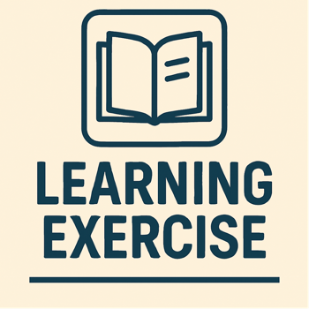

**Active Listening Exercise** designed for employees. This exercise aims to enhance active listening skills, which are crucial for effective communication, teamwork, and conflict resolution within the business environment.

### **Active Listening Exercise**

#### **Objective**

To develop and reinforce active listening skills among employees, ensuring better understanding, improved teamwork, and effective communication in various office scenarios.

### **Exercise Overview**

|  |  |
| --- | --- |
| ****Component**** | ****Details**** |
| ****Title**** | Active Listening Exercise: "Hear and Understand" |
| ****Duration**** | 60 minutes |
| ****Participants**** | Pairs or small groups of 2-4 employees |
| ****Materials Needed**** | - Scenario cards - Timer or stopwatch - Notepads and pens - Feedback forms |

### **1. **Introduction to Active Listening**

**Time:** 10 minutes

**Activity: Brief Presentation**

* **Content:**
  + Define active listening and its importance in the workplace.
  + Highlight key components of active listening:
    - **Paying Full Attention:** Focus on the speaker without distractions.
    - **Showing That You're Listening:** Use body language, eye contact, and verbal acknowledgments.
    - **Providing Feedback:** Paraphrase, summarize, and ask clarifying questions.
    - **Deferring Judgment:** Avoid interrupting and keep an open mind.
    - **Responding Appropriately:** Provide thoughtful and relevant responses.
* **Method:**
  + Use a PowerPoint presentation or flip charts to illustrate points.
  + Share real-life examples of effective and poor listening in the business environment.

### **2. **Active Listening Exercise: "Hear and Understand"**

**Time:** 40 minutes

**Activity: Paired Role-Playing with Scenario Cards**

**Instructions:**

1. **Form Pairs:**
   * Divide participants into pairs. If the group is large, form small groups of 3-4 where one person can speak and others listen.
2. **Distribute Scenario Cards:**
   * Each pair receives a scenario card depicting a common workplace situation that requires effective communication. Examples include:
     + **Scenario 1:** A conflict arises between kitchen staff over task assignments.
     + **Scenario 2:** A team member is struggling to keep up with the fast-paced kitchen environment.
     + **Scenario 3:** Planning a new menu requires input and collaboration from all team members.
     + **Scenario 4:** A customer has provided specific feedback about a service, and the chef needs to respond constructively.
3. **Role Assignment:**
   * In each pair, assign one person as the **Speaker** and the other as the **Listener**. After each scenario, roles will switch.
4. **Role-Playing:**
   * **Speaker:**
     + Reads the scenario and expresses their thoughts and feelings about the situation.
     + Must speak for 3-5 minutes, conveying their perspective clearly.
   * **Listener:**
     + Practices active listening skills:
       - Maintains eye contact and open body language.
       - Uses verbal acknowledgments like "I see," "Go on," or "I understand."
       - Avoids interrupting or judging.
       - Takes notes if necessary to remember key points.
   * **Feedback:**
     + After the Speaker finishes, the Listener paraphrases what was said to ensure understanding.
     + The Speaker provides feedback on how accurately they felt heard and understood.
5. **Role Switching:**
   * After completing one scenario, switch roles and repeat with a different scenario or the same one to reinforce learning.

### **3. **Group Debrief and Discussion**

**Time:** 10 minutes

**Activity: Group Sharing and Reflection**

* **Discussion Points:**
  + **What did you find challenging about being the Listener?**
  + **How did it feel to be truly heard and understood as the Speaker?**
  + **What active listening techniques did you find most effective?**
  + **How can you apply these active listening skills in your daily work environment?**
  + **What improvements would you like to make in your listening habits?**
* **Method:**
  + Bring all participants back together.
  + Facilitate an open discussion, encouraging everyone to share their experiences and insights.
  + Highlight common themes and effective strategies identified during the exercise.

### **4. **Conclusion and Action Steps**

**Time:** 5 minutes

**Activity: Setting Personal Goals**

* **Instructions:**
  + Ask each participant to identify one active listening skill they want to improve.
  + Have them write down a specific action they will take to enhance that skill (e.g., "I will maintain eye contact during conversations," "I will paraphrase what my colleagues say to ensure understanding").
* **Sharing:**
  + Encourage volunteers to share their personal goals with the group for accountability.

### **Additional Tips for Success**

* **Create a Safe Environment:** Ensure that all participants feel comfortable sharing and practicing without fear of judgment.
* **Encourage Participation:** Motivate everyone to actively engage in the role-playing and discussions.
* **Provide Constructive Feedback:** Focus on positive reinforcement and offer suggestions for improvement during feedback sessions.
* **Follow Up:** Schedule periodic check-ins to review progress on personal listening goals and address any ongoing challenges.

### 

### **Sample Scenario Cards**

|  |  |
| --- | --- |
| ****Scenario**** | ****Description**** |
| ****Scenario 1: Task Assignment Conflict**** | Two kitchen staff members disagree over who should handle the preparation of a new service. Discuss how to resolve the conflict amicably. |
| ****Scenario 2: Overwhelmed Team Member**** | A team member feels overwhelmed by the volume of orders and is struggling to keep up. Address their concerns and find ways to support them. |
| ****Scenario 3: New Menu Planning**** | The team is brainstorming ideas for a new seasonal menu. Facilitate a collaborative discussion to gather and integrate everyone's input effectively. |
| ****Scenario 4: Customer Feedback**** | A customer provides detailed feedback on a service, praising certain aspects while critiquing others. Respond constructively to the feedback. |
| ****Scenario 5: Miscommunication During Service Rush**** | During a busy service period, miscommunication leads to delayed orders. Identify the breakdown and improve communication strategies to prevent it. |

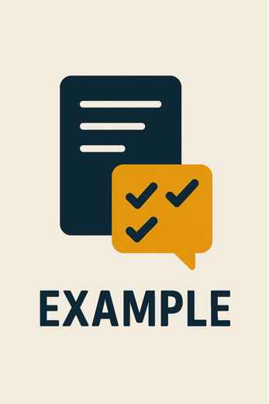

**STRUCTURE TABLES** for each component of your Surveys and Assessments course section.

### 1) **Surveys and Assessments**

Structured surveys and assessments to evaluate current communication skills and practices.

|  |  |  |  |  |
| --- | --- | --- | --- | --- |
| **Survey/Assessment Name** | **Objective** | **Format** | **Target Group** | **Frequency** |
| Communication Self-Assessment | Gauge individual perception of listening, clarity, and responsiveness | Likert-scale questionnaire | All staff | Onboarding + Quarterly |
| Peer Feedback Survey | Collect insights from colleagues on communication behaviours | 360-degree survey | Team members | Bi-annually |
| Communication Audit Checklist | Evaluate communication methods, tools, and flow within teams | Digital checklist | Team leads & managers | Annual |

### 2) **Data Analysis**

Template to analyse survey and assessment results, identifying trends, strengths, and areas for improvement.

|  |  |  |  |  |  |
| --- | --- | --- | --- | --- | --- |
| **Data Source** | **Metric/Indicator** | **Trend Observed** | **Strengths Identified** | **Areas for Improvement** | **Suggested Action** |
| Self-Assessment Survey | Active Listening Score | ↑ Improvement over 6 months | Strong team empathy | Inconsistent use of open-ended questions | Add reflective listening exercises |
| Peer Feedback | Clarity in Written Comms | ↓ Slight decline | Clear subject lines | Dense email bodies | Run “clear writing” clinic |
| Communication Audit | Tool Usage Consistency | Mixed | Teams standardised tools well | Departments lack alignment | Cross-department training on communication protocols |

### 3) **Feedback Sessions**

Personalised feedback template for employees based on their assessment results.

|  |  |  |  |  |  |
| --- | --- | --- | --- | --- | --- |
| **Employee Name** | **Assessment Highlights** | **Strengths** | **Development Areas** | **Recommended Resources** | **Follow-Up Date** |
| Alex R. | High empathy, low clarity in instructions | Listens well | Needs to give more structured feedback | “SBI Model” quick guide, 1:1 roleplay practice | 1 Month |
| Priya D. | Strong written communication | Email etiquette | Avoids verbal conflict resolution | Conflict Management eLearning | 6 Weeks |
| Thabo M. | Balanced skills, high engagement | Group facilitation | Can interrupt in fast-paced meetings | Active Listening audio practice | 2 Months |

### 4) **Action Planning**

Individualized action plans to address communication gaps and leverage strengths.

|  |  |  |  |  |  |
| --- | --- | --- | --- | --- | --- |
| **Employee** | **Goal** | **Action Steps** | **Timeline** | **Support Needed** | **Success Criteria** |
| Sam N. | Improve clarity in team meetings | Attend “Clear Briefing” workshop, use meeting agenda template | 4 weeks | Manager observation | 80% feedback score from peers |
| Julia S. | Increase active listening | Daily journaling, practice paraphrasing in meetings | 30 days | Peer practice buddy | Reflected listening used 3x/week |
| Brian L. | Deliver feedback with confidence | Use SBI model in weekly reviews, attend feedback clinic | 6 weeks | Feedback from direct reports | Positive upward feedback |

### 5) **Follow-Up and Evaluation**

Template to monitor progress through follow-up surveys and assessments.

|  |  |  |  |  |  |
| --- | --- | --- | --- | --- | --- |
| **Employee Name** | **Initial Score** | **Follow-Up Score** | **Improvement Observed** | **Next Steps** | **Evaluator Notes** |
| Nina P. | 65% | 78% | Improved listening and eye contact | Enrol in peer mentoring | Increased team engagement |
| Zanele K. | 80% | 82% | Slight improvement in written clarity | Maintain current practices | Consistent performer |
| Eric V. | 52% | 68% | Major improvement in feedback delivery | Start mentoring junior staff | Great attitude shift |



**STRUCTURE TABLES** for each component of your Surveys and Assessments course section.

### 1) **Surveys and Assessments**

Structured surveys and assessments to evaluate current communication skills and practices.

|  |  |  |  |  |
| --- | --- | --- | --- | --- |
| **Survey/Assessment Name** | **Objective** | **Format** | **Target Group** | **Frequency** |
| Communication Self-Assessment | Gauge individual perception of listening, clarity, and responsiveness |  |  |  |
| Peer Feedback Survey | Collect insights from colleagues on communication behaviours |  |  |  |
| Communication Audit Checklist | Evaluate communication methods, tools, and flow within teams |  |  |  |

### 2) **Data Analysis**

Template to analyse survey and assessment results, identifying trends, strengths, and areas for improvement.

|  |  |  |  |  |  |
| --- | --- | --- | --- | --- | --- |
| **Data Source** | **Metric/Indicator** | **Trend Observed** | **Strengths Identified** | **Areas for Improvement** | **Suggested Action** |
| Self-Assessment Survey | Active Listening Score |  |  |  |  |
| Peer Feedback | Clarity in Written Comms |  |  |  |  |
| Communication Audit | Tool Usage Consistency |  |  |  |  |

### 3) **Feedback Sessions**

Personalised feedback template for employees based on their assessment results.

|  |  |  |  |  |  |
| --- | --- | --- | --- | --- | --- |
| **Employee Name** | **Assessment Highlights** | **Strengths** | **Development Areas** | **Recommended Resources** | **Follow-Up Date** |
| Priya D. | High empathy, low clarity in instructions |  |  |  |  |
| Thabo M. | Strong written communication |  |  |  |  |
| Thabo M. | Balanced skills, high engagement |  |  |  |  |

### 4) **Action Planning**

Individualized action plans to address communication gaps and leverage strengths.

|  |  |  |  |  |  |
| --- | --- | --- | --- | --- | --- |
| **Employee** | **Goal** | **Action Steps** | **Timeline** | **Support Needed** | **Success Criteria** |
| Sam N. | Improve clarity in team meetings |  |  |  |  |
| Julia S. | Increase active listening |  |  |  |  |
| Brian L. | Deliver feedback with confidence |  |  |  |  |

### 5) **Follow-Up and Evaluation**

Template to monitor progress through follow-up surveys and assessments.

|  |  |  |  |  |  |
| --- | --- | --- | --- | --- | --- |
| **Employee Name** | **Initial Score** | **Follow-Up Score** | **Improvement Observed** | **Next Steps** | **Evaluator Notes** |
| Nina P. |  |  |  |  |  |
| Zanele K. |  |  |  |  |  |
| Eric V. |  |  |  |  |  |